Guided Inquiry: Analyzing Mass Balances in Multi-Unit and Reactive Systems
Classroom Activity / Self-Guided Study To be used with the Ethanol Production Flowsheet Simulator

Introduction & Objectives
In this activity, you will use the Ethanol Production Flowsheet Simulator to explore the fundamental principles of Chemical Engineering Mass Balances. By manipulating the inputs and analyzing the resulting stream compositions, you will learn how to:
- Apply Degree of Freedom (DoF) Analysis to ensure a system is mathematically solvable before conducting calculations.
- Define system boundaries for multi-unit processes.
- Apply the conservation of mass to non-reactive (mixing, separation) and reactive units.
- Understand reaction stoichiometry, limiting reactants, and fractional conversion in process flowsheets.

Part 1: Setting up and Getting Oriented
Open the Ethanol Production Simulator and use the default settings:
- Sucrose Feed Rate (S1): 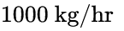
- Water Feed Rate (S2): 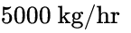
- Click Simulate if it has not already run.

Critical Thinking Questions (Part 1)
- Identify every unit operation (vessel) in this flowsheet. Which of these are non-reactive physical separations/mixtures, and which involve a chemical reaction?
  - M-101: __________________________________________
  - R-101: __________________________________________
  - T-101: __________________________________________
- Under the default inputs, list the total mass flow rate (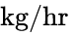) for the following streams:
  - S1 (Sucrose Feed): ________ 
  - S2 (Water Feed): ________ 
  - S3 (Reactor Feed): ________ 

Part 2: Degree of Freedom (DoF) Analysis - Fundamental Concepts
Before spending hours writing and trying to solve complex mass balance equations, engineers perform a Degree of Freedom (DoF) Analysis. This diagnostic tool determines if there is sufficient information to solve the system.
The Degree of Freedom equation for a system is:
Where:
- 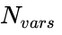 = Number of unknown stream variables (the species flow rates in each stream that we do not know).
- 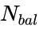 = Number of independent material balances we can write (usually equal to the number of chemical species present in the system).
- 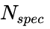 = Number of specified variables (known values directly given to us, such as inlet feed rates).
- 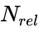 = Number of auxiliary relations (physical/chemical constraints, such as conversion rates, split ratios, or process requirements like water-to-sucrose ratios).

Interpreting the DoF:
- 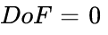: The system is perfectly specified. There are exactly enough independent equations to find a unique solution for all unknowns. You may proceed with solving!
- 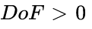: The system is under-specified. There are more unknowns than equations. You must find more information or make design assumptions to solve it.
- 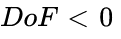: The system is over-specified. There are more equations than unknowns, meaning some specifications may contradict each other.

Part 3: Non-Reactive Mass Balances & DoF (The Mixer M-101)
Let's apply DoF analysis specifically to the Mixer (M-101).
The mixer has three streams connected to it: S1 (sucrose feed), S2 (water feed), and S3 (mixture exiting to the reactor). There are three species in play: Sucrose (S), Water (W), and Yeast (Y).
Let's list all possible individual species mass flow rates in each stream as our variables:
- Stream S1: 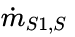, 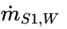, 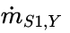
- Stream S2: 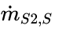, 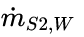, 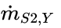
- Stream S3: 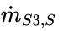, 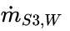, 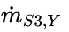
This gives 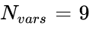 total stream variables.

DoF Counting Exercise for M-101:
- Known stream components (): We are given that 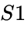 contains only sucrose () and 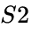 contains only water (). This means we can immediately set 4 variables to zero:
  - 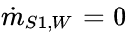, 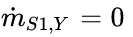, 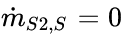, 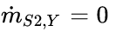.
  - We also specify the two inlet rates: 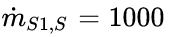, 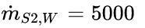.
  - What is the total count of specified variables ()? ________
- Auxiliary Relations (): The yeast is added to the mixer at a loading rate of 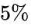 (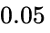) of the total raw feed (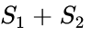). This can be written as:
  - What is the total count of auxiliary relations ()? ________
- Independent Material Balances (): Because we have 3 species (sucrose, water, yeast), we can write 3 independent material balances.
  - What is ? ________
- Calculate 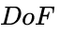:
Is the Mixer system solvable? ________
- Now, solve the Mixer balances:
Using the general mass balance equation at steady state (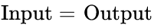):
  - Calculate : ________ 
  - Calculate : ________ 
  - Calculate : ________ 
  - Do these values match the stream label for S3 on your flowsheet? ________

Part 4: Reactive Mass Balances & DoF (The Fermenter R-101)
In Reactor R-101, sucrose undergoes reaction with water to produce ethanol and carbon dioxide gas:
When a reaction takes place, we must alter our DoF analysis. We can either write molecular species balances (which must include generation/consumption terms, adding an extra unknown called the "Extent of Reaction", ), or we can use atomic balances (where atoms are conserved, meaning  even with a reaction).
Using the Extent of Reaction Method, the DoF formula becomes:
Let's analyze Reactor R-101. It has 1 inlet stream () and 2 outlet streams ( and ).
The species involved are Sucrose, Water, Yeast, Ethanol, and 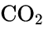 ( species).
-  (Unknown species flows in streams , , and ) = (calculated from solved flow rates + unknown flows in and ).
- 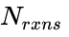 (Number of independent chemical reactions) = .

DoF Analysis for R-101:
- Material Balances (): We can write 1 molecular species balance for each of the 5 species.
  -  = ________
- Specifications (): We fully solved in Part 3, giving us 3 known inlet species flows. We also know that no sucrose, water, yeast, or ethanol exits in the gas vent ().
  -  = ________
- Auxiliary Relations (): The reactor operates at 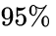 conversion (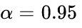) of sucrose, which gives us the relation:
We also know all the gas in is vented , meaning any generated  exits there.
  -  = ________
- Calculate :
Is the Reactor system solvable? ________
- Stoichiometric Calculations:
Using the molecular weights (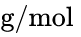): Sucrose (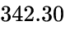), Water (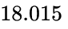), Ethanol (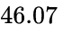),  (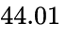):
  - Calculate the moles of sucrose entering the reactor in : ________ 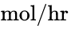
  - Calculate the moles of sucrose reacted (): ________ 
  - Using reaction stoichiometry, find the mass of ethanol produced: ________ 
  - Does this match the ethanol flow rate displayed in ? ________

Part 5: Separation Mass Balances & DoF (Distillation Column T-101)
The distillation column T-101 splits the reactor outlet stream () into a distillate product stream () and a bottoms waste stream (). There is no reaction in this unit.

DoF Counting Challenge for T-101:
Write down the elements of a DoF Analysis for T-101.
Hint: The species present are Sucrose, Water, Yeast, and Ethanol. The inputs in are already fully calculated.
- What are the unknown stream variables () in the outlet streams and ?
__________________________________________________________________
- Write down the independent material balance equations () that can be written for this unit.
__________________________________________________________________
- State the specifications () and physical/chemical relations () given in the column design (refer back to the column description in the Part 4 intro of the original guide, such as 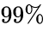 ethanol recovery, 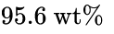 ethanol purity in distillate, and solids exiting in the bottoms).
__________________________________________________________________
- Prove that  for this distillation column.
__________________________________________________________________

Part 6: Overall System Mass Balance (The "Black Box")
By treating the entire chemical plant as a single "black box", we draw a system boundary that completely encapsulates all unit operations. Internal streams ( and ) vanish from our equations.
┌─────────────────────────────────────────┐
S1: Sucrose ────>│ │────> S7: CO2 Vent
│ ETHANOL PLANT │
S2: Water ────>│ (Boundary includes M-101, │────> S5: Ethanol Product
│ R-101, T-101, and Yeast) │
│ │────> S6: Bottoms Waste
└─────────────────────────────────────────┘

Critical Thinking & DoF Check:
- When analyzing the Overall System, why is the DoF analysis significantly simpler than doing unit-by-unit analyses?
__________________________________________________________________
- Under default operating conditions, verify the overall mass balance:

Part 7: Scenario Challenges
Change the inputs in the simulator to answer the following advanced questions.

Challenge A: Dilution Effects
Keep the Sucrose Feed Rate at , but increase the Water Feed Rate to 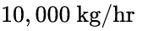. Click Simulate.
- Did the amount of ethanol produced in the reactor () change? Why or why not? Refer back to your DoF relations and conversion specifications.
__________________________________________________________________
- What happened to the concentration (weight fraction) of ethanol in the feed going to the distillation column ()? How might this affect the utility cost (steam heating) of running the distillation column in a real plant?
__________________________________________________________________

Challenge B: The Limiting Reactant Limit
Set the Sucrose Feed Rate to  and the Water Feed Rate to 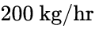. Click Simulate.
- What happened? Explain why the simulator threw an error using reaction stoichiometry. (Look back at the molar reaction ratios in Part 4).
__________________________________________________________________

